Task 2: Logistic Regression Analysis

Krescens Kok
Department of Technology, Western Governors University
D600: Statistical Data Mining
Keiona Middleton
2025 October 12

A. Create your subgroup and project in GitLab using the provided web link by doing the following:
• Clone the project to the IDE.
• Commit with a message and push when you complete each requirement listed in parts C2 through D4.

Note: You may commit and push whenever you want to back up your changes, even if a requirement is not yet complete.

• Submit a copy of the GitLab repository URL in the "Comments to Evaluator" section when you submit this assessment.
• Submit a copy of the repository branch history retrieved from your repository, which must include the commit messages and dates.

B. Describe the purpose of this data analysis by doing the following:
1. Propose one research question that is relevant to a real-world organizational situation captured in the provided dataset that you will answer using logistic regression in the initial model.

Research question: Can I predict whether a house is luxury or not?

2. Define one goal of the data analysis. Ensure that your goal is reasonable within the scope of the scenario and is represented in the available data.

The goal of this data analysis is to identify whether I can predict whether a house is luxury or not based on information such as the number of rooms, bathrooms, fireplaces, etc., by using a logistic regression model. A logistic regression model is great for predicting categorical outcomes and models the probability that a given input belongs to a particular class using the logistic function.

C. Summarize the data preparation process for logistic regression analysis by doing the following:
1. Identify the dependent and all independent variables that are required to answer the research question and justify your selection of variables.

The dependent variable is ‘IsLuxury.’ This is the variable I am trying to predict based on the other variables. ID has been dropped from the dataset because this column won’t help generalize a pattern in the data.

Price: I kept this because the price could be an indicator of the house being luxurious or not. Typically, more expensive houses are more luxurious.
SquareFootage: I kept this because it makes sense that the bigger the square footage of a house, the more luxurious a house would be.
NumBathrooms/NumBedrooms: I kept this because typically the more bathrooms and bedrooms there are, the more luxurious a house is.
BackyardSpace: I kept this because backyard space can also make an impact on whether a house is luxury or not. Backyard space is land, and typically, land makes a house more luxurious.
CrimeRate: I kept this because the crime rate tells us more about the kind of area a house is in, which could impact whether it is considered luxurious or not.
SchoolRating: I kept this because the school rating could determine whether the house is in a good area, which could make a house luxurious.
AgeOfHome: This could mean a house is luxurious or not because some old houses have unique architecture, making it luxurious.
DistanceToCityCenter: This is important because the city has a lot of things to do, which could determine whether a house is luxurious or not.
EmploymentRate: This could have an impact on whether a house is luxurious or not because a higher employment rate means better economic health and a better area, making the house more luxurious.
PropertyTaxRate: This could have an impact on the luxury of a house because the higher the property tax rate could mean that the area is wealthier, leading to a luxurious house.
RenovationQuality: This could have an impact on the luxury of a house because if it is newly renovated, then it could be considered a luxurious house.
LocalAmenities: This could have an impact on whether a house is luxurious or not because there are many things to do nearby, meaning that it is a luxurious place to live.
TransportAccess: This could impact whether a house is luxurious or not because if the house is closer to transportation, it is more convenient, making a house more luxurious.
HouseColor: This could impact whether a house is luxurious or not because the house could be painted a modern color, changing its look.
Garage: This could impact whether a house is luxurious or not because houses with garages are typically considered luxurious.
Floors: This could impact whether a house is luxurious or not because the more floors there are, typically, the house would be considered luxurious.
Windows: Most people enjoy having natural light in their house, so having more windows could mean that the house is luxurious
PreviousSalePrice: This is an indicator of historical value, which could tell a lot about the house, such as whether it was well-maintained or high-quality materials were used. This could make a house luxurious.

2. Describe the dependent variable and all independent variables from part C1 using descriptive statistics (counts, means, modes, ranges, min/max), including a screenshot of the descriptive statistics output for each of these variables.

Dependent variable:

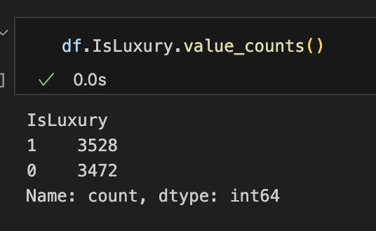
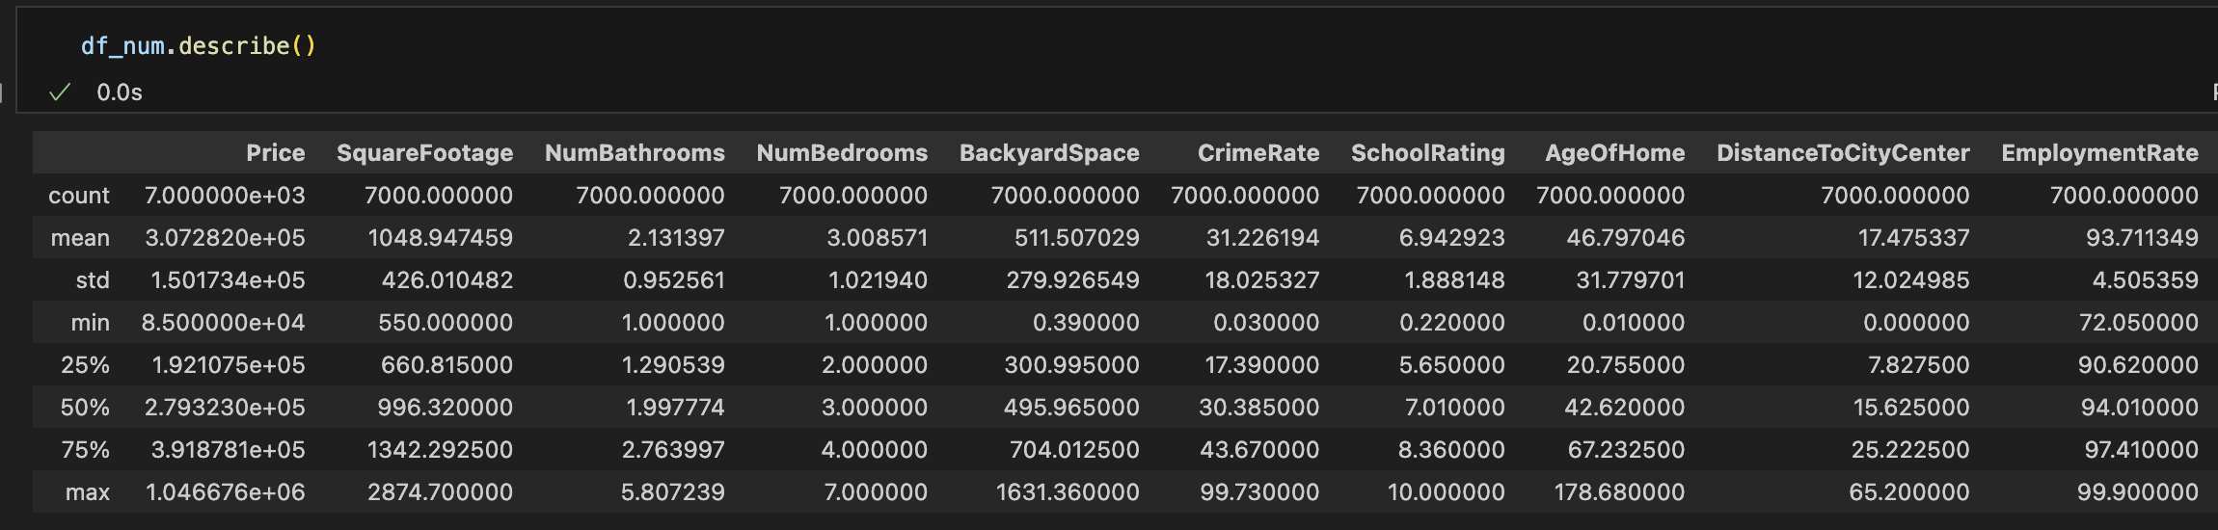
Independent numerical variables:
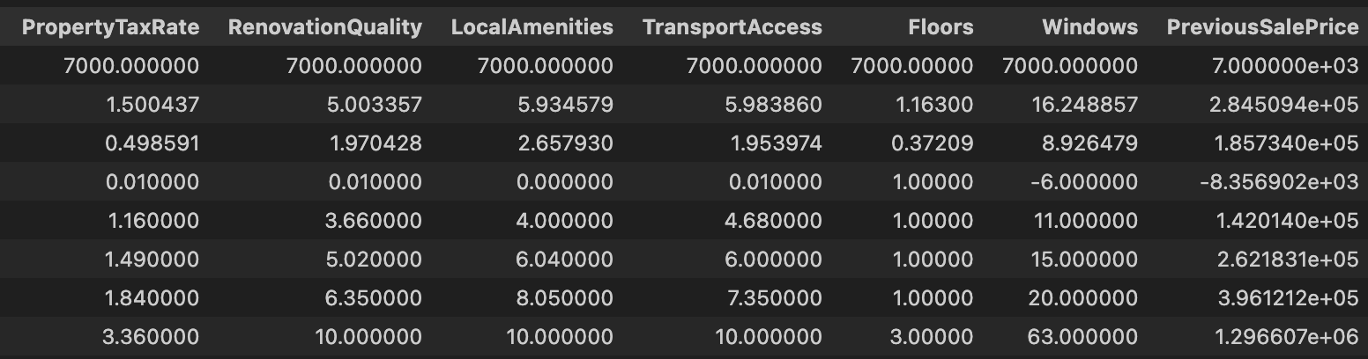

Independent categorical variables: Modes:

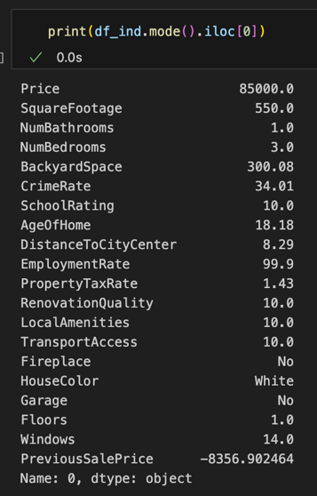
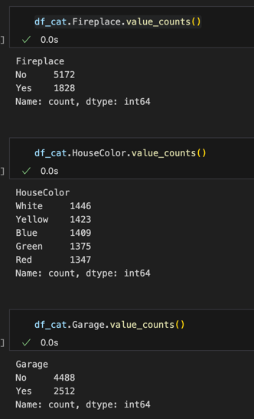
3. Generate univariate and bivariate visualizations of the distributions of the dependent and independent variables from part C1, including the dependent variable in the bivariate visualizations.

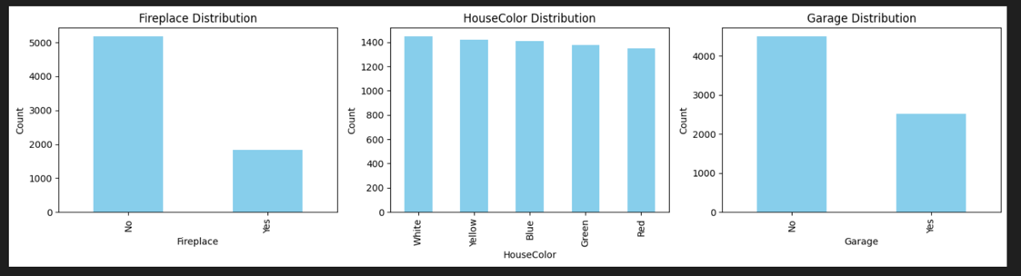
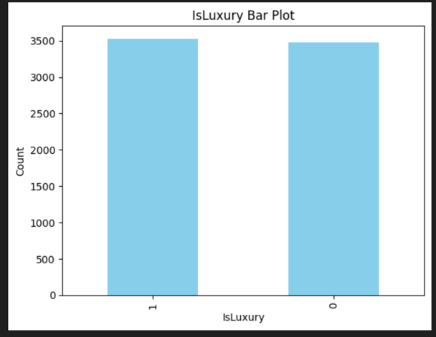
Univariate:
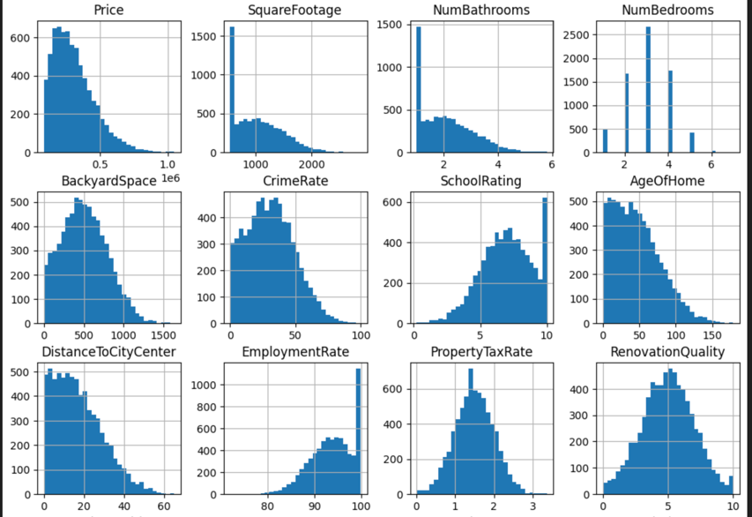
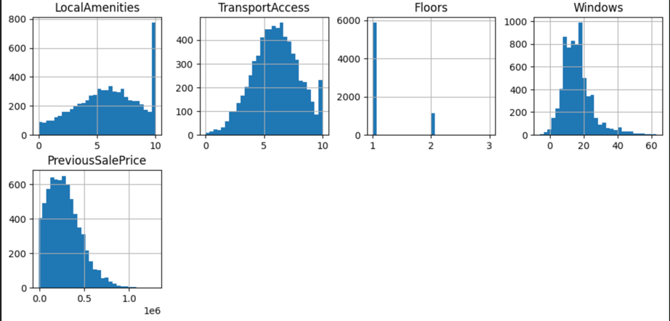
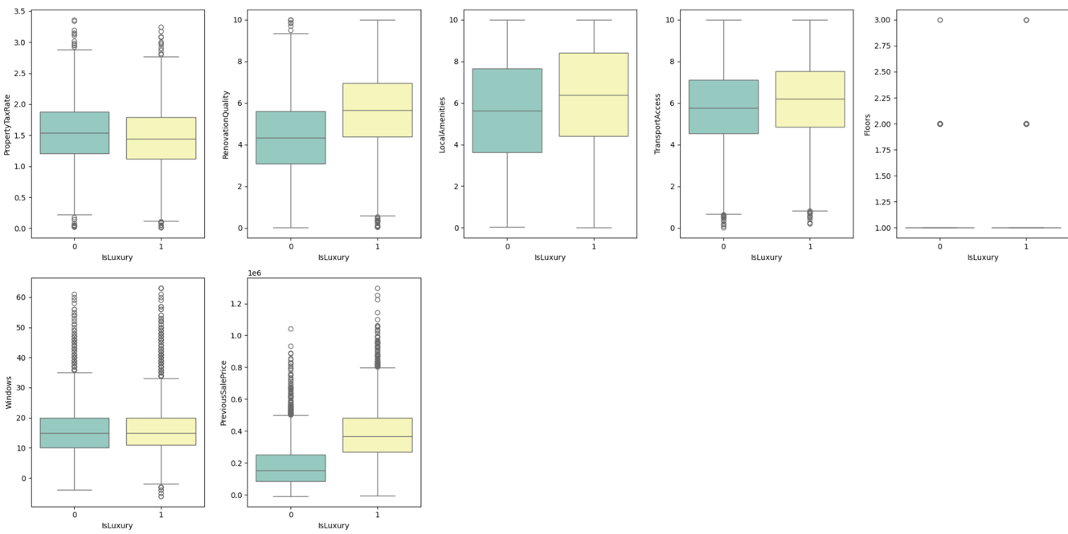
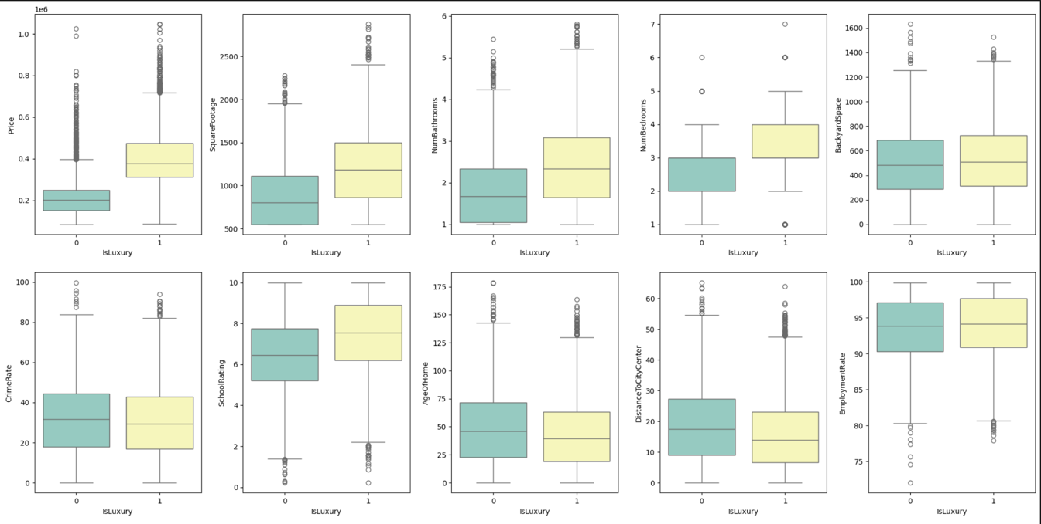
Bivariate:
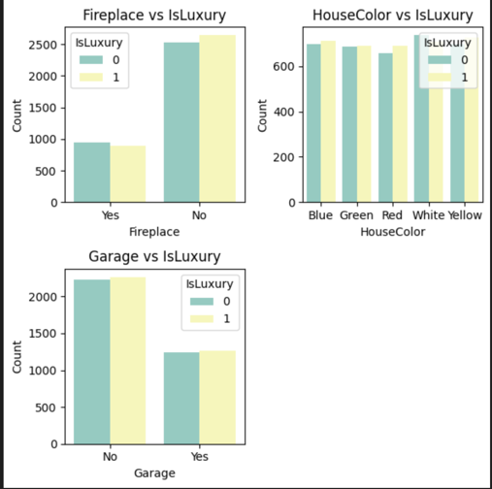
D. Perform the data analysis and report on the results by doing the following:
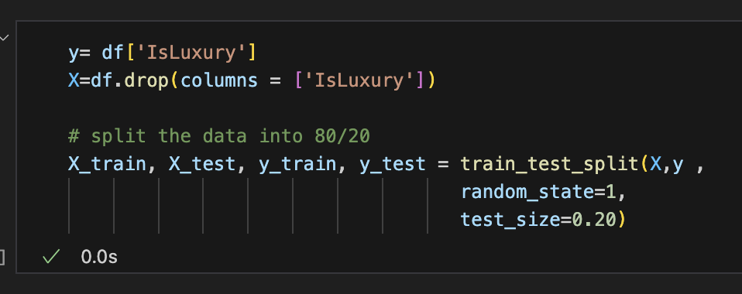
1. Split the data into two datasets, with a larger percentage assigned to the training dataset and a smaller percentage assigned to the test dataset. Provide the file(s).

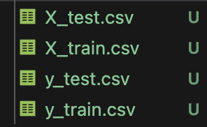

2. Use the training dataset to create and perform a regression model using regression as a statistical method. Optimize the regression model using a process of your selection, including but not limited to, forward stepwise selection, backward stepwise elimination, and recursive selection. Provide a screenshot of the summary of the optimized model or the following extracted model parameters:
• AIC
• BIC
• pseudo R²
• coefficient estimates
• p-value of each independent variable

Before Optimization:
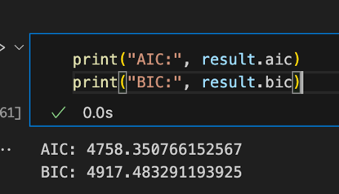
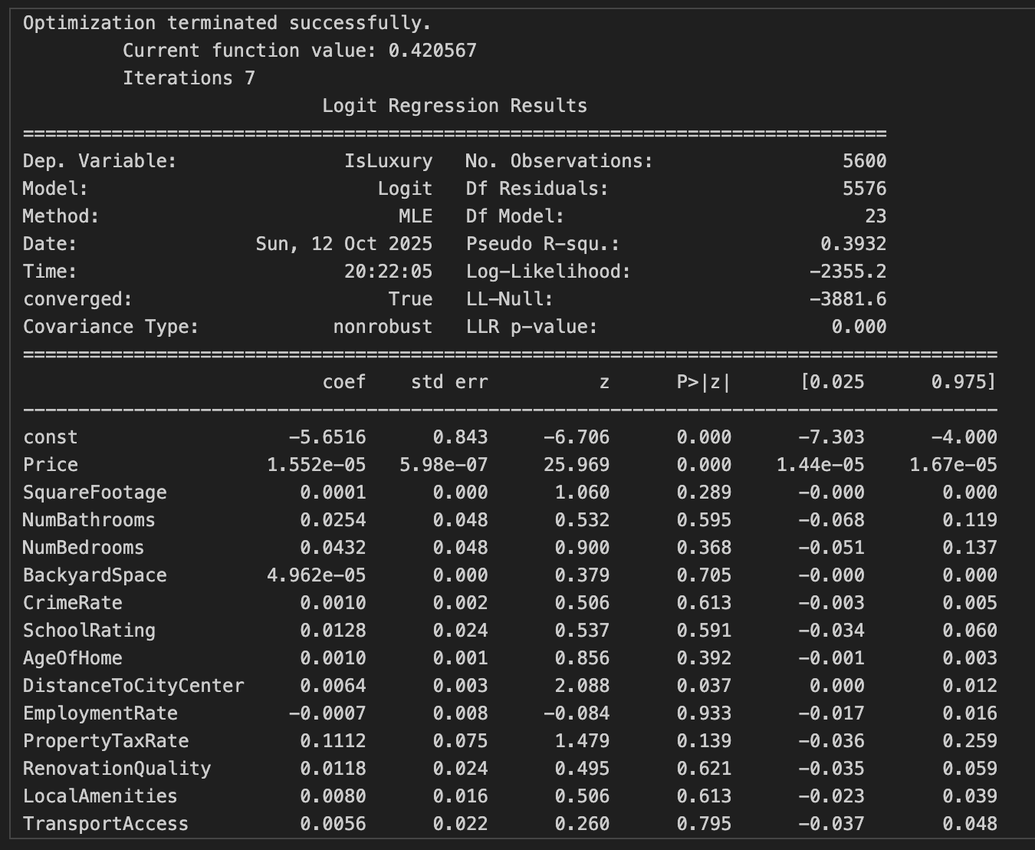

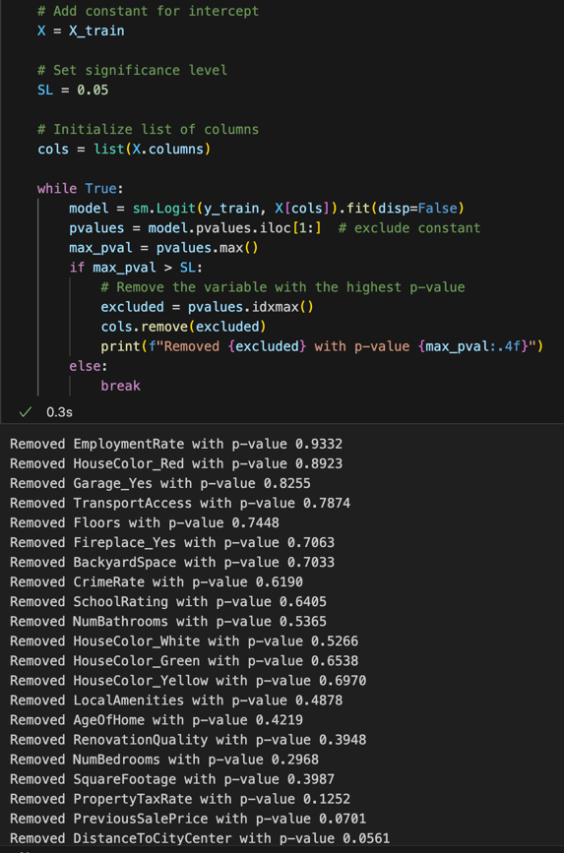
Remove features with backwards stepwise elimination:
After Optimization:
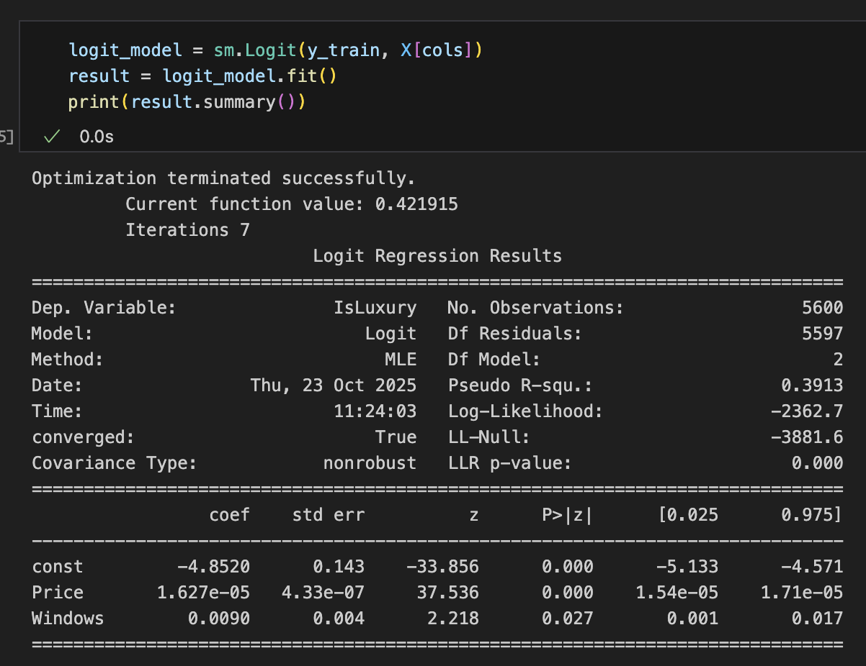
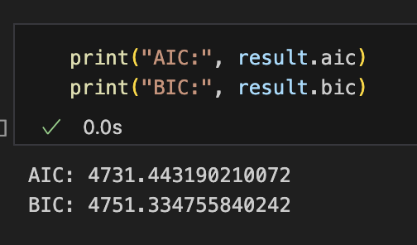

3. Give the confusion matrix and accuracy of the optimized model used on the training set.

Before Optimization: After Optimization:
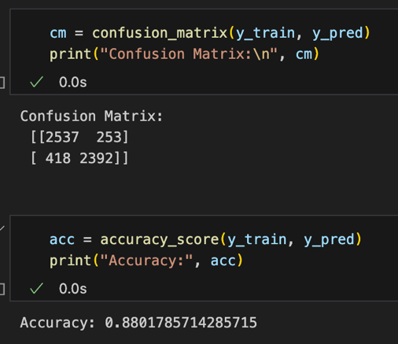
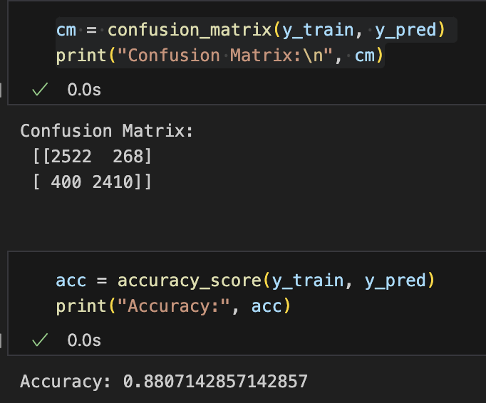

4. Run the prediction on the test dataset using the optimized regression model from part D2 to evaluate the performance of the prediction model on the test data based on the confusion matrix and accuracy. Provide a screenshot of the results.

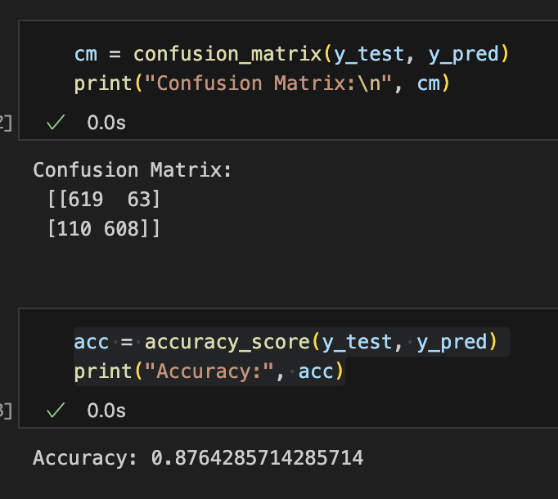
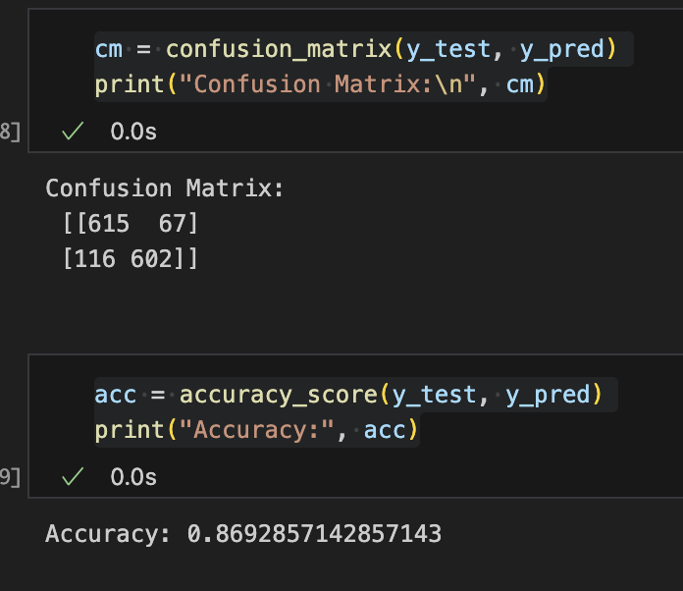
Before Optimization: After Optimization:

E. Summarize your data analysis by doing the following:
1. List the packages or libraries you have chosen for Python or R and justify how each item on the list supports the analysis.

- import pandas as pd: Used for creating data frames, transforming data frames (e.g. dropping columns), and reading/writing csv files.
- import matplotlib.pyplot as plt: Used for creating univariate and bivariate graphs to understand the distributions of each variable and the independent vs dependent variable.
- import seaborn as sns: Used to create bar plots for the categorical variables and the dependent variable.
- from sklearn.model_selection import train_test_split: Used to split the data frame into test and train
- import statsmodels.api as sm: Used to apply the logit model on the data frame to get the summary of the model, which includes the R-squared, pseudo R-squared, coefficients, etc.
- from sklearn.metrics import confusion_matrix, accuracy_score: Used to get the confusion matrix and accuracy score from the model output.
- from statsmodels.stats.outliers_influence import variance_inflation_factor: Used to check if the variables had multicollinearity.
- from statsmodels.stats.stattools import durbin_watson: Used to identify autocorrelation in the residuals of a regression model. This was important to identify before performing backward elimination.
- from sklearn.metrics import confusion_matrix, accuracy_score, classification_report, confusion_matrix, recall_score, precision_score, f1_score: Used to calculate metric scores from the confusion matrix.
- import sys: Used to identify the Python version being used.
- Import warnings: This wasn’t required, but it allowed the output to look cleaner as it ignored the warning messages if a function is going to be deprecated soon.

2. Discuss the method used to optimize the model.

I chose a backward elimination for optimizing the model as it iterates through the features and eliminates the less significant features through a loop and stops once all the features have a significant value of less than .05. Keeping features with a significant value of less than .05 means that there is strong evidence against the null hypothesis and the feature does have an impact on the dependent variable. Using this approach reduces overfitting and helps the model generalize to data. Optimizing the model helped the accuracy of the model increase by ~.007 for the test set.

3. Justify the approach discussed in part E2 that was used to optimize the model.

Using backward elimination for optimizing the model was chosen because the method starts with all the variables and iterates to identify the most meaningful predictors. In addition, the method improves model interpretability since it removes variables, and so it becomes easier to understand which variables actually have an impact on the dependent variable. Using this method also reduces overfitting and helps the model generalize the data because it’s meant to reduce the number of variables in the final model output. Lastly, as mentioned above, the method helped increase the accuracy of the model by a small amount but still cleaned up the model interpretation with more meaningful variables.

4. Summarize at least four assumptions of logistic regression.
1. Large sample size – The model requires a large sample size to produce reliable and stable results (GeeksforGeeks, 2025).
2. No multicollinearity – Independent variables should not be highly correlated with each other.
3. Binary Dependent Variable – The dependent variable can only take 2 categories (GeeksforGeeks, 2025).
4. Independent observations – Each data point is assumed to be independent of the others, and there shall be no correlation or dependence between the input samples (GeeksforGeeks, 2025).

5. Provide evidence that the assumptions from part E4 were verified by providing either a code snippet or a screenshot.

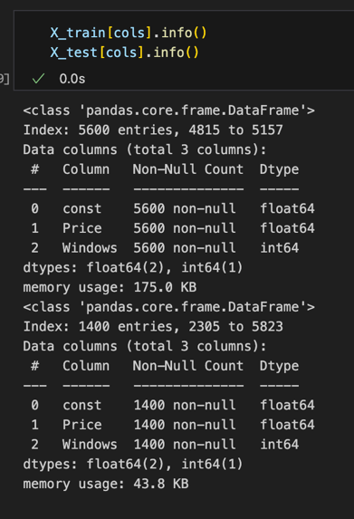
1. Large sample size: We can see here in the df.info(), that there are 7000 records, which is a sufficient number to be considered a large sample size (Logistic Regression Power Analysis | STATA Data Analysis Examples, n.d.). There are 5600 records in the training set and 1400 in the testing set to get a total of 7000.

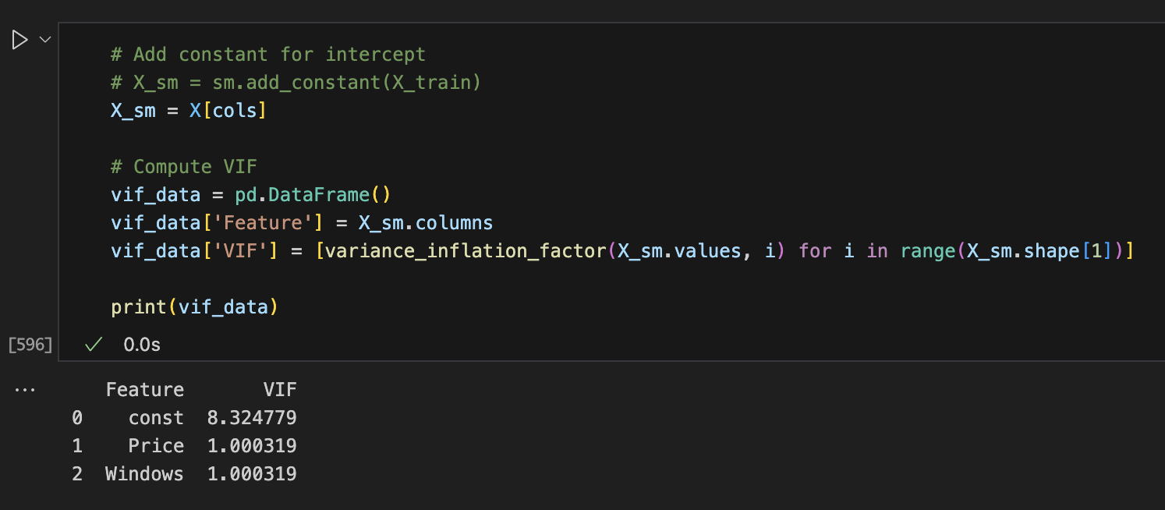
2. No Multicollinearity: This was verified by using the function variance_inflation_factor to identify if there is a correlation between variables. Since all of the VIF scores are below 10, this means that there is little to no multicollinearity between the variables.

3. Binary Dependent Variable: The dependent variable consists only of ‘1’ and ‘0’. ‘1’ represents that the house is luxurious, and ‘0’ represents that it’s not luxurious.
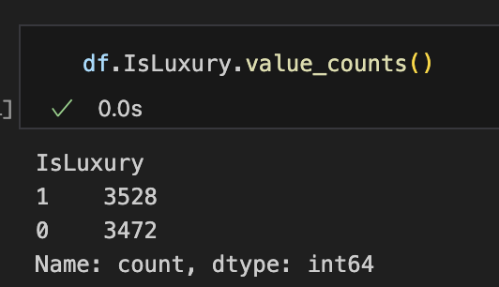

4. Independent Observations: There are no duplicate rows in the dataset, verifying that the observations are independent of one another. I am also assuming that the data was collected accurately and that the data was collected on each individual house, resulting in independent observations.

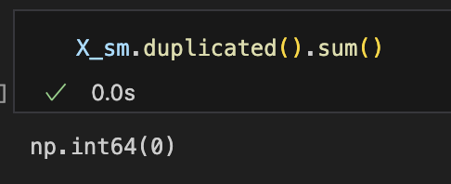

6. Provide the regression equation and discuss the coefficient estimates

logit(IsLuxury(p)) = -4.852 + .00001627x_{Price} + .009x_{Windows}

The constant of -4.852 is the log odds of IsLuxury = 1 when all the other predictors are 0, meaning that the price of a house is 0 and there are 0 windows. This is the baseline for the model, but it isn’t realistic.

The coefficient of price means that the log odds of a house being luxurious increase by .00001627 every time the price increases by a dollar.

The coefficient of windows means that the log odds of a house being luxurious increase by .009 every time there is an additional window.

7. Discuss the model metrics by addressing each of the following:
• the accuracy for the test set
The accuracy for the test set was .876 = 87.6%. This means that the model can accurately predict whether a house is luxury or not 87.6% of the time. This is a strong performance of the model, indicating that the model is reliable.
• the comparison of the accuracy of the training set to the accuracy of the test set
The accuracy of the training set was .8801 = 88.01%, while the accuracy of the test set was 87.6%. Although the model performs slightly better on the training set, the model is still a good fit to the test data because it’s new data that hasn’t been used in the model fitting. Since the scores are so close, this shows that the model isn’t overfitting the data and shows that the model generalizes well on unseen data.
• the comparison of the confusion matrix for the training set to the confusion matrix of the test set
Test Set: Training Set:
[[619 63] [[2537 253]
[110 608]] [ 418 2392]]
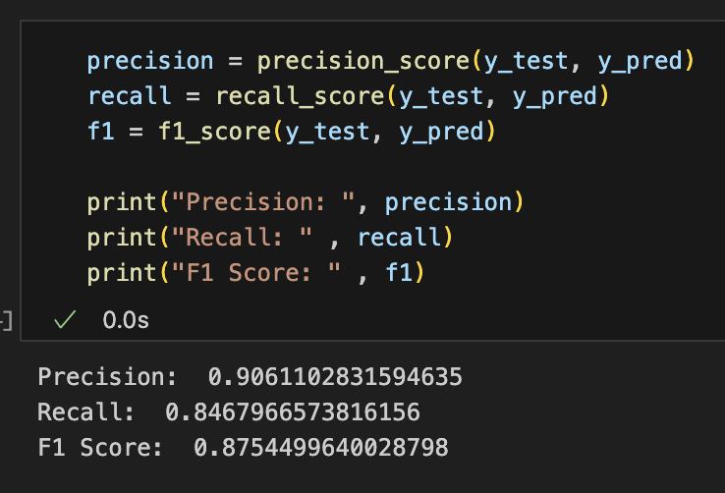
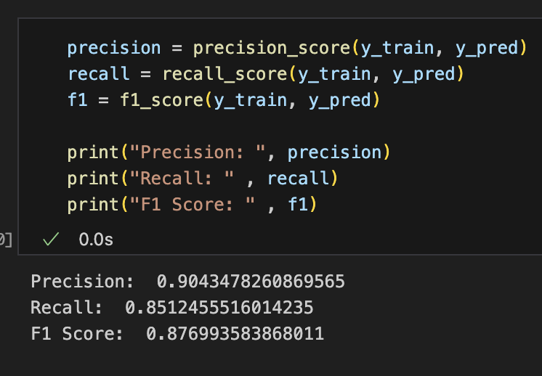

Using the confusion matrix, the precision, recall, and f1 scores can be calculated. The precision score is calculated by true positives (TP) / (TP + FP), recall is calculated by TP/ (TP + FN), and F1 score is 2 x (precision x recall) / (precision + recall). Precision tells us how accurate the positive predictions are, the recall tells us how well the model finds all the positives, and lastly, the F1 score measures how accurate and comprehensive the model is.

Based on the values of both the training and test sets, the values are very similar, which means that the model generalizes well. The model is consistent for data that it has not seen before, making it a good fit to continue to make predictions of whether a house is luxurious or not.

8. Discuss the results and implications of your prediction analysis.

The results reveal that price and windows both have a positive impact on whether a house is luxurious or not. The accuracy of the training set is .88, and the accuracy of the test set is .87, which are both great scores for accuracy and show that the model performs well on new data. In addition, since the accuracy scores are so similar, this means that the model didn’t overfit the data. Although the accuracy score is high, there could still be additional factors that could contribute to the luxury of a home.

The implications of these findings are meaningful for individuals who want to buy a luxury home, and they can use these insights to prioritize features that have the strongest impact on whether the house is considered a luxury home or not. In addition, there could be other factors that may have an impact on the categorization of a house being luxury or not. For example, the material of a home (brick, stone, etc.).

Another implication of these findings is that a logistic regression assumes a linear relationship between the predictor and the log odds of the outcome, which makes it difficult for variables that have a nonlinear relationship with the dependent variable. In addition, outliers or missing values could also affect the coefficient estimates and introduce bias in the model.

9. Recommend a course of action for the real-world organizational situation from part B1 based on your results and implications discussed in part E8.

Circling back to the research question of “Can I predict whether a house is luxurious or not?” the answer is yes. The model demonstrated a strong ability to predict whether a house is luxury or not, with very little to no overfitting, proving that the model does well with unseen data. The recommended course of action is for the business to look at other features that could potentially affect the classification, such as house material (brick, stone, etc). If the business is looking to build a house, I would recommend that they build a house that has many windows. If the business is looking to buy a house that is considered luxury, I would recommend that they find a house with a higher price and a house that has a lot of windows. Lastly, if the business is looking to sell a house, I would recommend looking at the same features of buying a house, as the same variables would help indicate whether a house is luxury or not, potentially increasing the sales.

References

GeeksforGeeks. (2025, August 2). Logistic regression in machine learning. GeeksforGeeks. https://www.geeksforgeeks.org/machine-learning/understanding-logistic-regression/
Logistic Regression Power Analysis | STATA Data Analysis Examples. (n.d.). https://stats.oarc.ucla.edu/stata/dae/logistic-regression-power-analysis/

